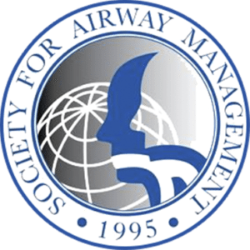

FELLOWS AND JUNIOR FACULTY NEW SPEAKER FORUM
“LIGHTNING ROUND” PRESENTATIONS
SUBMISSION GUIDELINES AND INSTRUCTIONS

The SAM Annual Meeting will bring together the world’s leading airway educators and investigators in San Diego, CA to discuss the best practices in multidisciplinary airway management.

We encourage airway and anesthesiology fellows, junior faculty, and any other early career individuals in their respective field, to give a 10-minute “lightning round” presentation on a current topic within airway management of their choosing, as a way to gain visibility and participation within the SAM community.

Applicants must register for the conference, and be available on Sunday, September 20, 2026, from 10:45 to 11:55 am to present during the New Speaker Forum ‘Lightning Presentations” session.

To apply:
1) Review the guidelines below,
2) Complete the “Lightning Round” Template Submission form.
3) Submit the application form and contact information at the following website:
https://samhq.com/2026-submissions/

Deadline: Applications must be submitted by end of day, Sunday May 31, 2026

Notifications: Notifications of acceptance/rejection will be sent by Sunday, June 7, 2026

Contact: For any questions, concerns, please contact: SAM2026submissions@gmail.com

Guidelines:

- Presenters should be an Anesthesiology fellow in good standing or early career faculty/individual, within 5 years of training. Airway Fellowship trainees are especially encouraged to apply.
- Each application/proposal is reviewed in relationship to current practices and future developments in airway management. Content should highlight an interesting topic in airway management, new interesting research, or controversial topic.
- Applications will be reviewed by the SAM Annual Meeting Program Committee. Acceptability of each application/proposal will be evaluated on the organization and clarity of the proposal content. The submission should include learning objectives.
- Selected individuals will be asked to prepare PowerPoint slides and a 10-minute presentation

