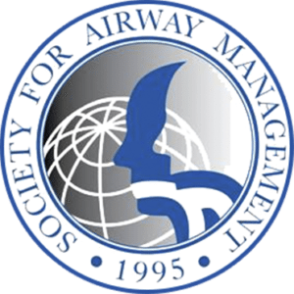

INTERNATIONAL CHAPTER WHITE PAPER PANEL PRESENTATIONS
SUBMISSION GUIDELINES AND INSTRUCTIONS

The SAM Annual Meeting will bring together the world’s leading airway educators and investigators in San Diego, CA to discuss the best practices in multidisciplinary airway management.

Members of countries which belong to the SAM International Chapters are welcomed to give a 10 minute and participate in a following 10 minute moderated question and answer period. Presentations should be based on a big picture or cutting-edge airway management topic relevant to their country.

Applicants must register for the conference, and be available on Sunday, September 20th, 2026, from 9:40 to 10:45 to present and answer questions during the International Chapter White Paper Panel session.

To apply:
1) Review the guidelines below,
2) Complete the “White Paper” Template Submission form, found in the submission link, and
3) Submit the application form and contact information at the following website: https://samhq.com/2026-submissions/

Deadline: Applications must be submitted by end of day, Sunday, May 31, 2026

Notifications: Notifications of acceptance/rejection will be sent by Sunday, June 7, 2026

Contact: For any questions, concerns, please contact: SAM2026submissions@gmail.com

Guidelines:

- One submission will be selected per country for representation. Three countries will be selected.
- Individuals may encouraged to submit more than one application per unique topic, up to 3, via separate submissions.
- Each application/proposal is reviewed in relationship to current practices and future developments in airway management. Content should highlight a big picture or cutting-edge airway management topic which is ideally and namely relevant to the member country.
- Applications will be reviewed by the SAM Annual Meeting Program Committee. Acceptability of each application/proposal will be evaluated on the organization and clarity of the proposal content. The submission should include learning objectives.
- Selected individuals will be asked to prepare PowerPoint slides, a 10 minute oral presentation, and be prepared to participate in a 15 minute moderated question and answer period with a panel of experts and questions from the audience.
- Only applications submitted using the White Papers proposal site will be considered. Emailed applications unfortunately will not be reviewed. An email confirming receipt of proposal receival will be sent within 1 business day.

