An individual Airway Lead and All Members of an Airway Committee should have the following goals:

- Formation of an airway leads group or committee which involves representation from all those within a hospital/institution with experience and an interest or role in airway management.

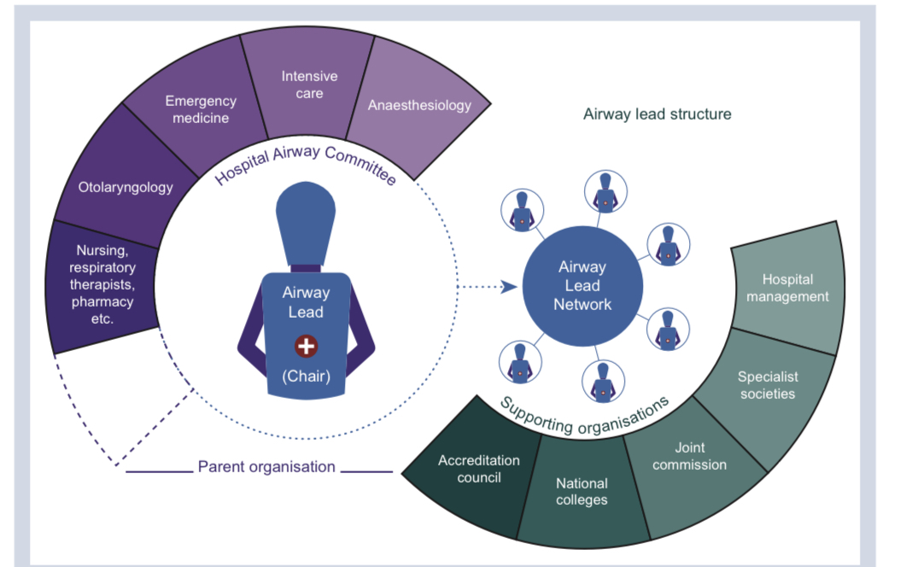
An Airway Committee is ideally composed of the following individuals:
Br J Anaesth 2022;128(2):225-229

- Coordinate supply, quality and storage of airway equipment for their institution including standardization and location of airway carts (trolleys).

- Promote the use of current practice management guidelines regarding airway management throughout the institution.

- Coordinate training and education, including airway workshops, and simulation sessions (if available), for all clinicians involved in advanced airway management.

- Conduct audits of major adverse events related to airway management in their institution.

6. Address Human Factors issue regarding Airway Management.

